The Architecture of the Application
In this section we will introduce the architecture (design) of the whole Application that comprises three layers, and discuss the use and communication between these layers. Every layer will be described in detail in its own section of this manual.

Introduction
The Application is be divided into three basic layers. These layer are depicted in the following picture.

Participants and Their Mutual Interaction
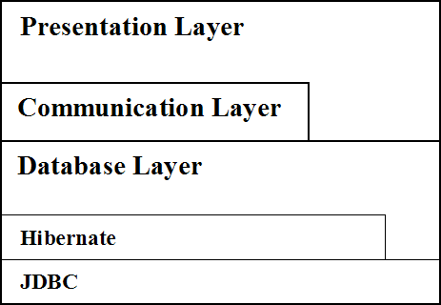Drawing 1: Layers of the Application
Every layer can only call the layer that is below it. A lower layer cannot call an upper one, it can just carry out requests passed by higher layers.

The Database Layer
The Database Layer serves as an intelligent encapsulation of the Hibernate ORM API and JDBC API. It provides a unified interface that can be safely used in combination with the Communication Layer. This is why several operations withing the Database Layer must be performed carefully, as we will see later. The Database Layer is responsible for the management of the database connection and all database operations.
The Database Layer also performs user privileges verification and saves information about every operation with the database which can be later used to restore the state of a record or of the whole database. There are several other security measures incorporated in the Database Layer that will be discussed in detail later. They include: safe creation of queries that do not allow the User to execute malicious SQL queries, and safe manipulation with records.

The Communication Layer
The Communication Layer is the mediator between the Presentation Layer and the Database Layer in case the remote connection is required, i.e. connection to a remote Database Layer. It ensures the communication over the network - passing the arguments and returning requested results.
The Communication Layer is based on the RMI. In fact it is the RMI that provides the network communication, argument passing, and results retrieval. The only non-trivial part is establishing the connection to the remote Database Layer at the beginning which is managed by the Presentation Layer.
The Communication Layer provides the same interface as the Database Layer so that the Presentation Layer can work with the Communication Layer in the same manner as if it worked with the Database Layer itself.

The Presentation Layer
The Presentation Layer is the topmost layer. This layer consists of several parts that are known as the Plantlore Client. This layer provides most of the functionality - it comprises the GUI and the business logic of the Application. All parts of this layer are designed to use the Model-View-Controller architecture; all parts are responsible for carrying out different tasks in the Application.
As you can see from the Drawing 1. the Presentation Layer can access the Database Layer directly without getting the Communication Layer involved. This happens during the local connection and can save the overhead connected with the Communication Layer.
In case the connection to a remote Database Layer is required, the Communication Layer is involved. The Presentation Layer establishes the connection to the Server via the Communication Layer and instructs it to create a remote Database Layer. Then the Communication Layer provides the connection for the Presentation Layer to use.

The Server
The Server was not introduced yet. Let's have a look at the architecture containing the Server.
As you can see the Presentation Layer can establish a connection to the Server via the Communication Layer. The Server itself does not use Database Layers, it merely creates them and manages them. The Presentation Layer asks the Server to create the remote Database Layer and then the Presentation Layer can work with it using the Communication Layer.
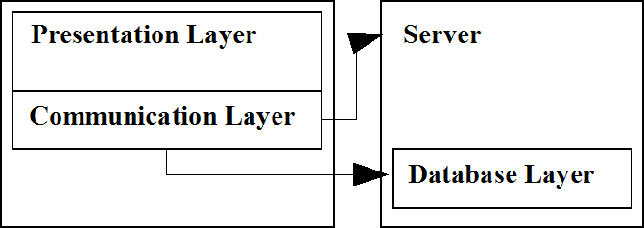Drawing 2: Architecture with the Server
The only responsibility of the Server is to create and manage its Database Layers including their proper destruction if something happens to the Client - if the Client crashes or if the network connection is lost.

